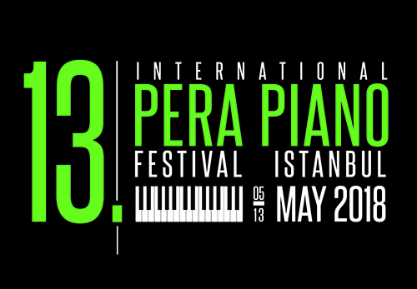
13th INTERNATIONAL PERA PIANO FESTIVAL- ISTANBUL

MAY 05-13 2018

SOLO PIANO COMPETITION

SPECIFICATION AND APPLICATION FORM AGES BETWEEN 11-14

Application Requirements
- Pay attention to fill in the form completely and legible.

The parents will sign the application form for the applicants under the age of 18.

The candidates must convey the application form, 2 snapshop photos, a copy of ID card, bank receipt and the music notes of the works which will be played to Pera Fine Arts High School should post or deliver by hand till March 10, 2018.

Works must be played by heart.

Competitors must appear with their concert costume on the scene.

You can reach to the music notes of the Turkish composers by applying to aysim@perasanat.com.tr address.

The list of the participants will be published on www.perafestival.org website starting April 11, 2018.
- It is mandatory that the candidates who will participate to the competition are registered on registration desk at least 1 hour before the competition time conveyed to them.
- It’s definitely forbidden to take photos and to do a recording during the competition.

The participation fee for the competition is 200 TL. The competitors must deposit the participation fee till March 10th ,2018 to the account of PERA MÜZİK GARANTİ BANKASI GALATASARAY ŞUBESİ IBAN:TR47 0006 2000 0680 0006 6864 24

The decision of the jury can’t be criticized.

Awards

The winners and the competitors who get the best mention “ … performer” will be rewarded with money and gifts. The prizes will be published on the website www.perafestival.org.

Specification for the Participants:
- The candidates between 11-14 ages can participate to the competition. Candidates aged between 11 and 12 and candidates aged between 13 and 14 will be evaluated separately. The age calculation will be done according to the date on which the competition will be held.
- The date of the competition will be published on the website www.perafestival.org

“A certificate of participation” will be given to the participant and his/her trainer.
- It’s compulsary that the competitors who are placed in the competition and selected by the jury perform a program with the piece or pieces selected by jury from the competition program in the award ceremony on Sunday, May 13th, 2018.

Competition program for the participants:

A composotion from Baroque Period,

Options:

J.S.Bach, 1 of the 2 or 3 voice Inventions, prelude and fugues
- one part from Baroque Period Suits or Partitas,

One sonatta from Scarlatti

One study (except slow studies) (Czerny op. 299, 636, 740, Moszkowski op.72, Chopin, Liszt, Rachmaninoff, Chopin, Cramer, Scriabin, A.A. Saygun, Prokofiev)

A Work from Classical Period

Options;
- One part from Sonata or Sonatinas (Sonate Allegro form), Variations, Fantasies, Rondo

A composition from Turkish composers,

A composition selected by candidate,

13TH INTERNATIONAL PERA PIANO FESTIVAL
ISTANBUL
MAY 05-13, 2018
SOLO PIANO COMPETITION AGES BETWEEN 11 -14
APPLICATION FORM

Name, Surname: _____________________________________________________________

Place of Birth: __________________________ Date of Birth:_________________________

School Name: _______________________________________________________________

Trainer/Teacher’s Name, Surname: ______________________________________________

Program

Composer:____________Composition: _______________op._____No._____ Duration:____

Composer:____________Composition: _______________op._____No._____ Duration:____

Composer:___________ Composition: _______________op._____No._____ Duration:____

Composer:___________ Composition: _______________op._____No._____ Duration:____

Composer:____________Composition: _______________op._____No._____ Duration:____

“I attend to the festival for the first time.” ___________ “I attend to the festival for the _________ time.” “I will play the works by heart in the festival.”_____________________ “I will play the works with music notes.”__________________

Home Address: ______________________________________________________________
_____________________________________District:________________City:____________
e- mail address:_______________________________Phone Nr: _____________________
Teacher’s Contact Information:__________________________________________________
Mother’s Name, surname: _______________________Phone Nr: ______________________
Father’s Name, Surname: ________________________Phone Nr: _____________________

I have read the terms. The information I mentioned is correct.

Date of Application: __________________________________

Parent’s Name, Surname: _______________________________ Signature: _____________

Student’s signature: ________________

